
Subject: Programming with Java
ASSIGNMENT No : 17
TITLE : Write a Java program to demonstrate the use of Swing and Applets

Name: Avdhoot Mohite Class: CSE A2
PRN: 25070122056 Batch:25-29

Problem Statement
Write a Java program to demonstrate the use of Swing and Applets
Learning Objectives
To develop graphical user interfaces using Swing components and Applets.
Theory
Swing is Java's GUI toolkit that provides lightweight components such as buttons, labels, text fields, and menus. Applets were small Java programs embedded in web pages for interactive applications. Although Applets are obsolete, Swing remains an important framework for desktop application development. Swing supports platform-independent graphical interfaces.
Outcome
The programs were successfully implemented to demonstrate the use of Java Swing components for developing graphical user interfaces. A Student Registration Form and an Employee Registration Form were created using Swing components such as labels, text fields, buttons, and dialog boxes. The employee form successfully accepted employee details and displayed the entered information in a dialog box.
Conclusion
Thus, the experiment successfully demonstrated the development of graphical user interfaces using Java Swing. Different Swing components were used to create registration forms and handle user input. The Employee Registration Form also demonstrated how entered information can be displayed using a dialog box. The experiment provided an understanding of basic GUI development in Java.

Exercise
1. Create a simple Student Registration Form GUI using Swing.
Java Program
import javax.swing.*;
import java.awt.*;
import java.awt.event.*;

public class assignment17a extends JFrame {

JTextField nameField, rollField, courseField;
JButton registerButton;

assignment17a() {
setTitle("Student Registration Form");
setSize(400, 300);
setLayout(new GridLayout(4, 2, 10, 10));
setDefaultCloseOperation(JFrame.EXIT_ON_CLOSE);

JLabel nameLabel = new JLabel("Student Name:");
JLabel rollLabel = new JLabel("Roll Number:");
JLabel courseLabel = new JLabel("Course:");

nameField = new JTextField();
rollField = new JTextField();
courseField = new JTextField();

registerButton = new JButton("Register");

add(nameLabel);
add(nameField);

add(rollLabel);
add(rollField);

add(courseLabel);
add(courseField);

add(new JLabel(""));
add(registerButton);

registerButton.addActionListener(new ActionListener() {
public void actionPerformed(ActionEvent e) {
JOptionPane.showMessageDialog(
assignment17a.this,
"Student Registered Successfully!\n" +
"Name: " + nameField.getText() + "\n" +
"Roll Number: " + rollField.getText() + "\n" +
"Course: " + courseField.getText()
);
}
});

setVisible(true);
}

public static void main(String[] args) {
new assignment17a();
}
}

OUTPUT:
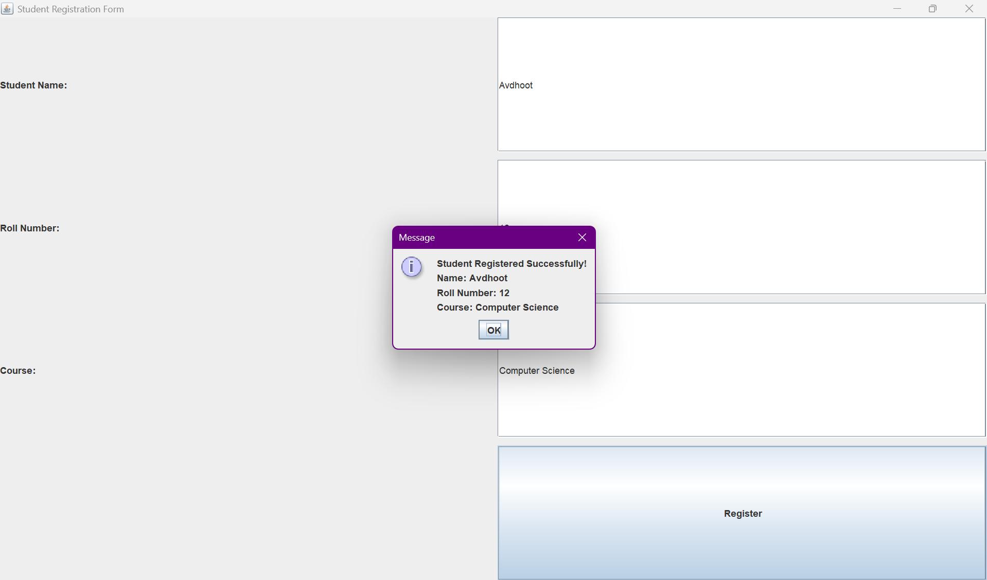

2. Create a simple Employee Registration Form using Java Swing GUI that takes employee details such as Employee ID, Name, Department, and Salary. Display the entered information in a dialog box.
Java Program
import javax.swing.*;
import java.awt.*;
import java.awt.event.*;

public class assignment17b extends JFrame {

JTextField idField, nameField, departmentField, salaryField;
JButton submitButton;

assignment17b() {
setTitle("Employee Registration Form");
setSize(450, 300);
setLayout(new GridLayout(5, 2, 10, 10));
setDefaultCloseOperation(JFrame.EXIT_ON_CLOSE);

JLabel idLabel = new JLabel("Employee ID:");
JLabel nameLabel = new JLabel("Name:");
JLabel departmentLabel = new JLabel("Department:");
JLabel salaryLabel = new JLabel("Salary:");

idField = new JTextField();
nameField = new JTextField();
departmentField = new JTextField();
salaryField = new JTextField();

submitButton = new JButton("Submit");

add(idLabel);
add(idField);

add(nameLabel);
add(nameField);

add(departmentLabel);
add(departmentField);

add(salaryLabel);
add(salaryField);

add(new JLabel(""));
add(submitButton);

submitButton.addActionListener(new ActionListener() {
public void actionPerformed(ActionEvent e) {
JOptionPane.showMessageDialog(
assignment17b.this,
"Employee Details\n\n" +
"Employee ID: " + idField.getText() + "\n" +
"Name: " + nameField.getText() + "\n" +
"Department: " + departmentField.getText() + "\n" +
"Salary: " + salaryField.getText()
);
}
});

setVisible(true);
}

public static void main(String[] args) {
new assignment17b();
}
}

OUTPUT:
